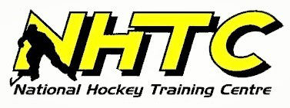

**NHTC Covid Update November 10, 2020**

Due to the recent health orders set out by the Provincial Health Officer, effective immediately NHTC will be returning to PHASE 2 safety protocols. Which means all Beginner, Preschool Learn to Skate classes, Wednesday Adult Co-Ed, and 3 on 3 games are cancelled for 2 weeks (resuming Tuesday November 24th). Ryan’s 3-on-3 will continue as scheduled but will change to a hockey skills practice format. NO game situations will be allowed for 2 weeks. Anyone planning on running a game can switch to practice mode ensuring 2M social distance is always met or get a full refund or credit for the missed ice.

All other NHTC programs; Level 1&2, Level 3&4 classes, Ryan Carignan High Performance classes and private lessons will continue as scheduled while maintaining 2M social distance at all times on the ice.

We will be enforcing a strict Mask policy in which everyone will wear a Mask at all times keeping 2M social distance at the rink especially in the hallways, dressing rooms and in the viewing area. We limited visitors to one parent or responsible person come into the rink with any skater. This means no siblings or others will be allowed in the building, unfortunately no extenuating circumstances during these 2 weeks will be allowed.

All NHTC staff and coaches will be checked daily to ensure all are safe and healthy while at the rink.

If anyone is unwell, please stay home and we will gladly offer a full refund or credit without any notice. Anyone unable, unwilling or uncomfortable coming to the rink can get a full refund or credit. We ask everyone to please revisit our safe practice protocols and ensure full adherence.

Please contact the office at 604-534-7825 if you have any questions.

Thank you for your understanding and cooperation as we all try to navigate through these trying times.

Kind regards,

NHTC Langley